# **Cactus Micro tiny size arduino compatible board plus WIFI chip esp8266**

Features

* Built-in ESP8266 WIFI module (Optional)
* ATmega32U4 running at 3.3V/8MHz
* Supported under Arduino IDE v1.0.6
* On-Board micro-USB connector for programming
* 4 x 10-bit ADC pins
* 12 x Digital I/Os (5 are PWM capable)
* Rx and Tx Hardware Serial Connections

Getting Started

Open Arduino IDE and choose board "LilyPad USB" to start playing with your Cactus Micro in just a few easy steps.

Description

Cactus Micro is our integrated developement board, we have mixed Arduino with WIFI into a single board. It is targeted for makers to develop low power Internet-Of-Things (IoT) projects quickly and easily.

The micro-controller unit (MCU) is Atmel ATmega32U4 and the WIFI chip is ESP8266.

How It Works

* The ESP8266 chip communicates with Atmega32U4 through the SoftwareSerial or Serial (hardware serial port). It can be switched by a jumper. The default port for communicattion is SoftwareSerial port (RX: 11, TX: 12)
* The pin 13 is connected to pin CH_PD of ESP8266. Put the pin 13 high to enable ESP8266 chip.

Support

All other questions regarding Cactus Micro, please visit [our Forum](http://bbs.aprbrother.com/conversations/arduino)

Technical Details

* About ESP8266 chip
* Serial communication

**Cactus Micro Pinout**

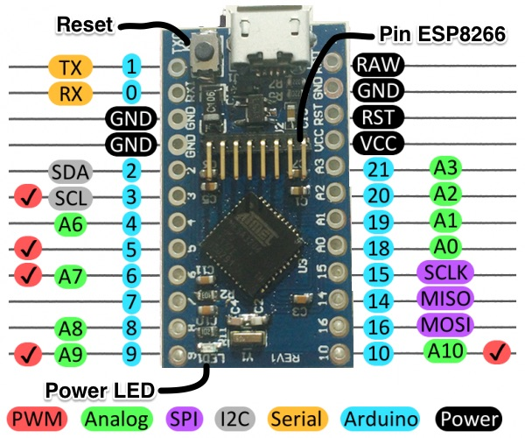

Specification

| Microcontroller | [Atmel ATmega32U4](http://www.atmel.com/devices/atmega32u4.aspx) |
| --- | --- |
| Wireless Chip | ESP8266 |
| Operating Voltage | 3.3V |
| Input Voltage | 5V (USB)  4.3-12V (RAW)  Note: Use either one power source at a time, otherwise you will damage the board. |
| Clock Speed | 8MHz |
| Connectivity | WIFI  micro-USB  Serial  I2C  SPI |
| Flash Memory | 32KB (of which 4 KB used by bootloader) |
| SRAM | 2.5k |
| EEPROM | 1k |
| Dimensions | 1.3 x 0.7" |
| I/O Pins | 18 |

**Package Contains**

* Cactus Micro x 1
* ESP8266 module (ESP-11) x 1
* Pins (Not soldering) x 1

More detail, please [refer the wiki](http://wiki.aprbrother.com/wiki/Cactus_Micro)